**Chapter 4**

**ART GALLERY MANAGEMENT SYSTEM**

**Results and Snapshots**

The project is complied and executed with apache server on xampp.We have put in few screen shots in here to show the working of application.

**Snapshots:**

Figure4.1: Login page for customer in online art gallery website where customer can purchase.

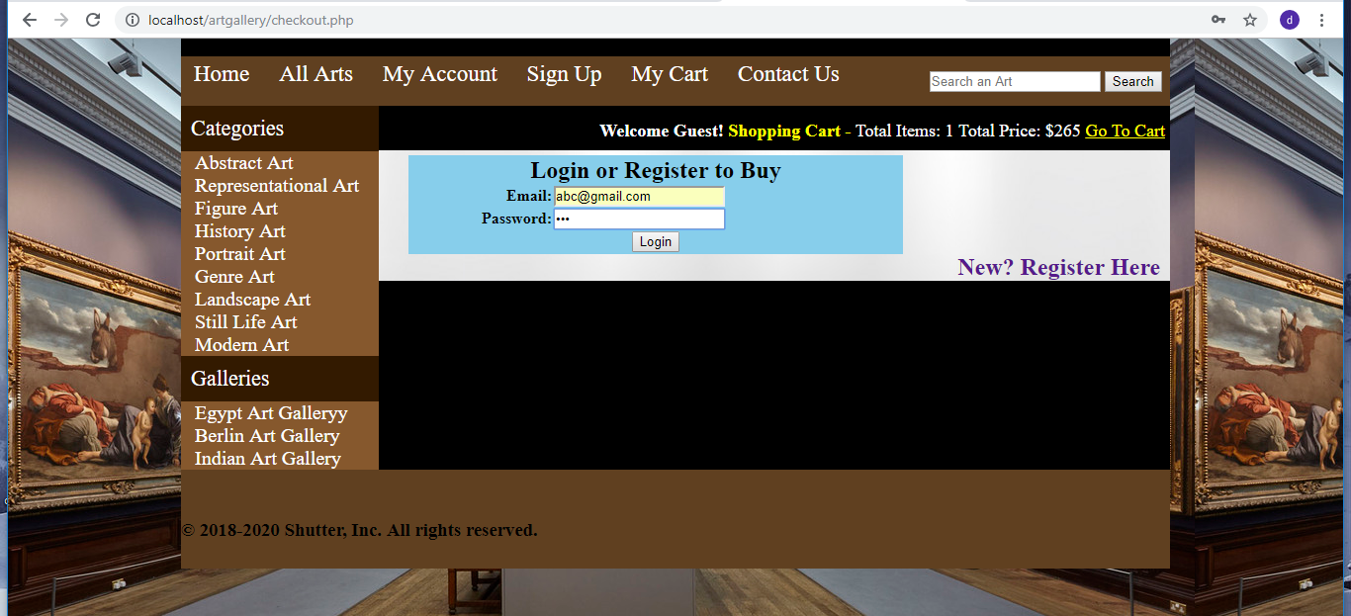

**Figure4.1:** Customer Login Page

Figure4.2 represents the error when customer enters incorrect login details.

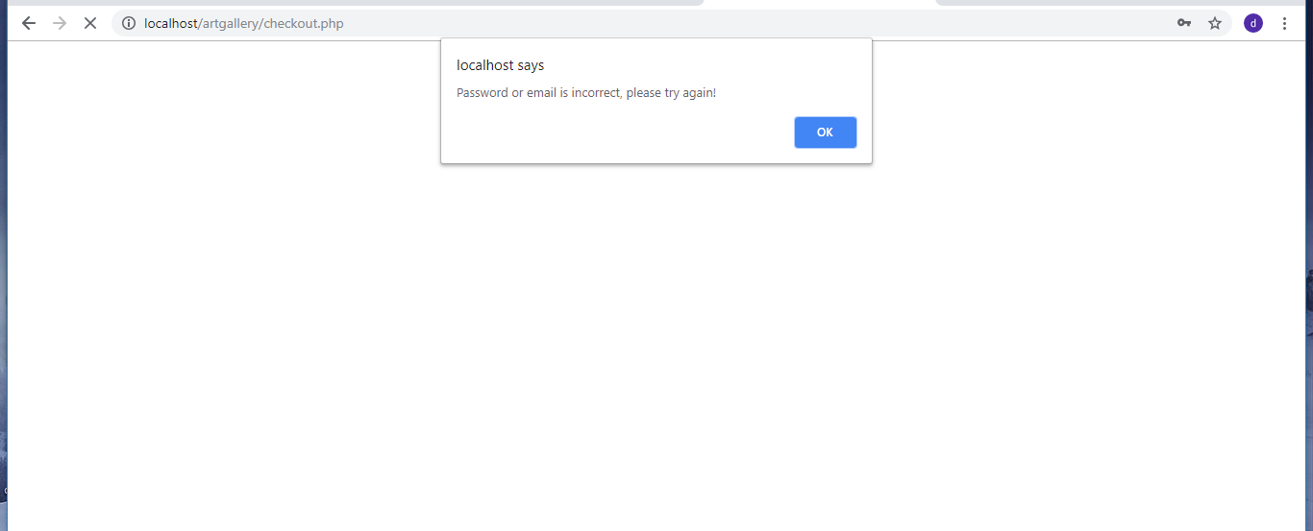

**Figure4.2:** Error login Page

Figure4.3 shows the update account window for customer.

**Dept. of CSE, JSSATE**

**Page 17**

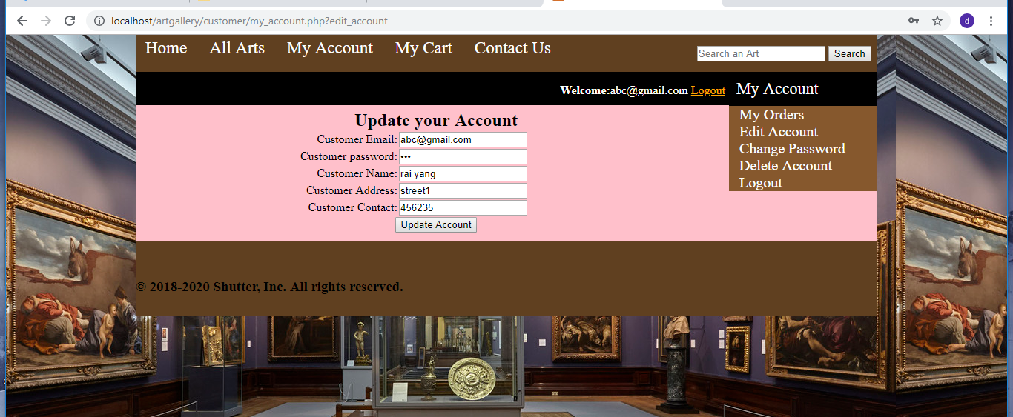

**ART GALLERY MANAGEMENT SYSTEM**

**Figure4.3:** Customer Account Page

Figure4.4 customer registration page.

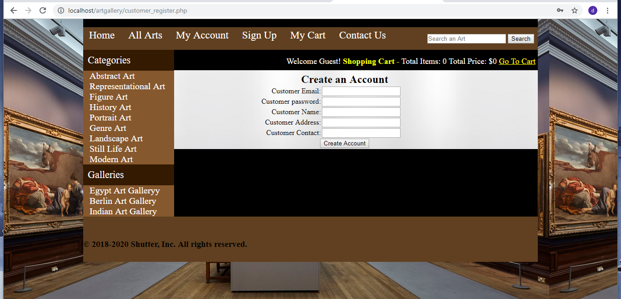

**Figure4.4:** Customer Create Account Page

Figure4.5 views all orders for login customer.

**Dept. of CSE, JSSATE**

**Page 18**

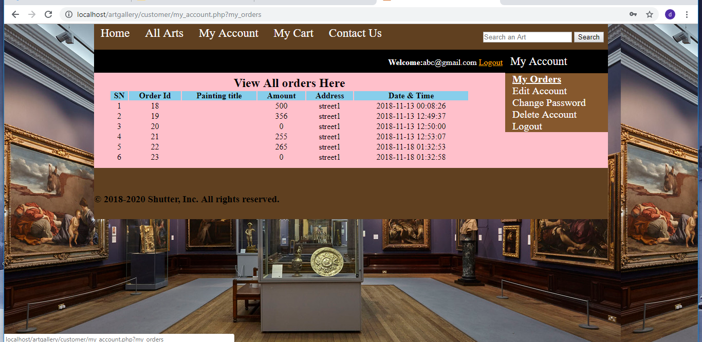

**ART GALLERY MANAGEMENT SYSTEM**

**Figure4.5:** Customer orders Page

Figure4.6 shows the insert gallery page..

**ART GALLERY MANAGEMENT SYSTEM**

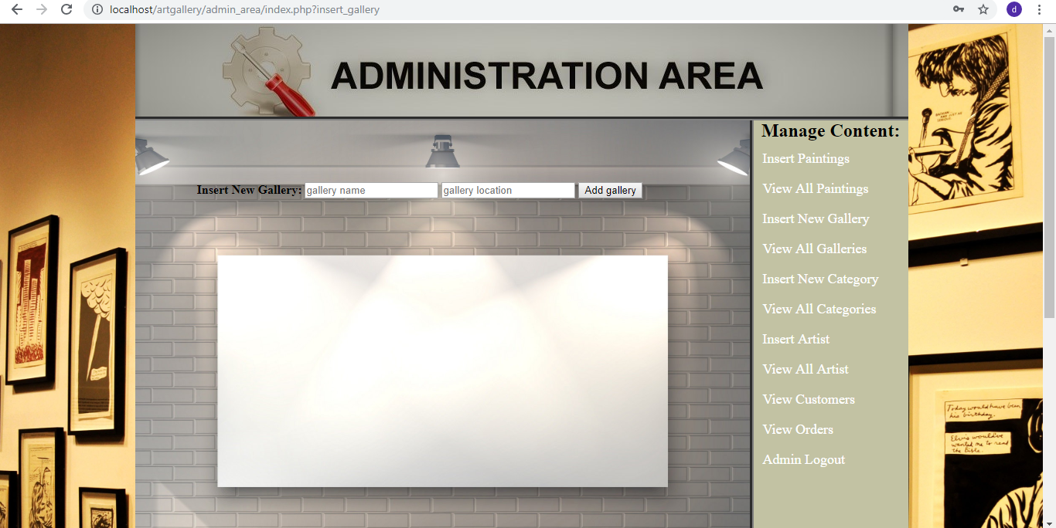

**Figure4.6:** Insert Gallery Page

Figure4.7 shows the cart for the customer.

**Dept. of CSE, JSSATE**

**Page 19**

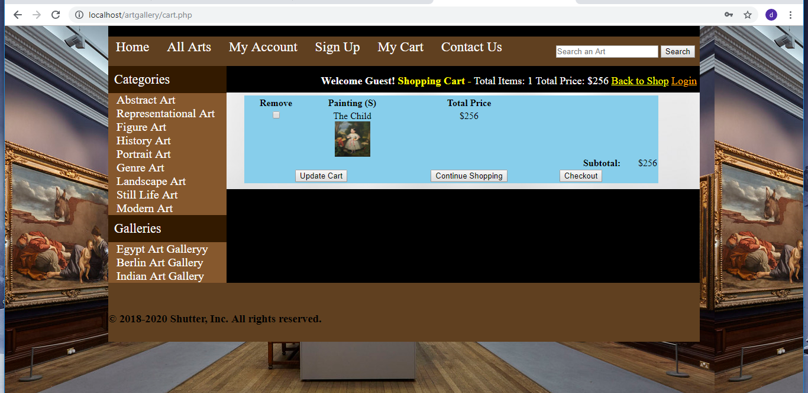

**ART GALLERY MANAGEMENT SYSTEM**

**Figure4.7:** Customer Cart Page

Figure4.8 shows the order confirmation page.

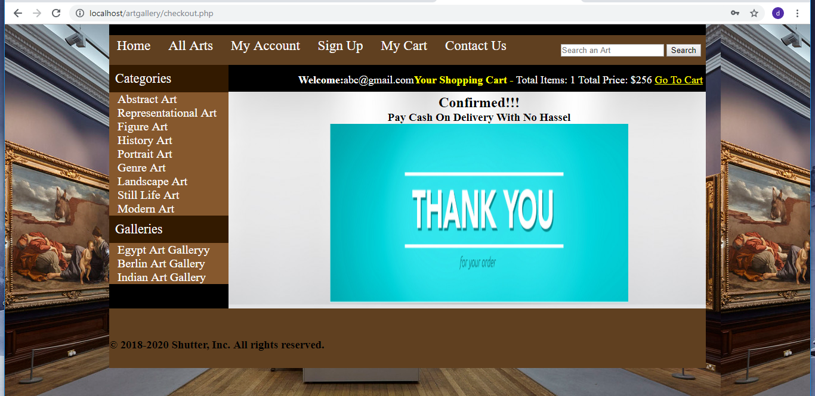

**Figure4.8:** Customer Order Confirmation Page

Figure4.9: shows the home page.

**Dept. of CSE, JSSATE**

**Page 19**

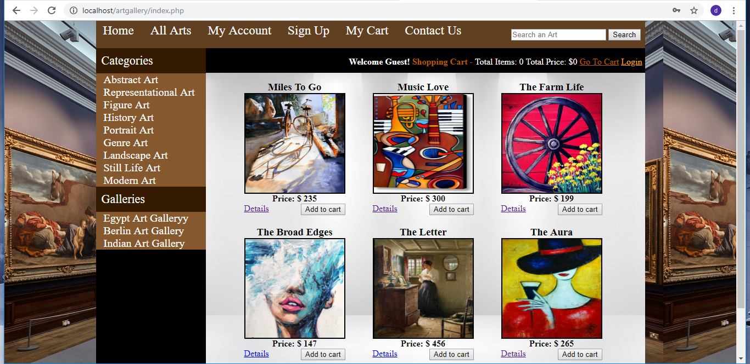

**ART GALLERY MANAGEMENT SYSTEM**

**Figure4.9:** Home Page

Figure4.10 shows the admin login page.

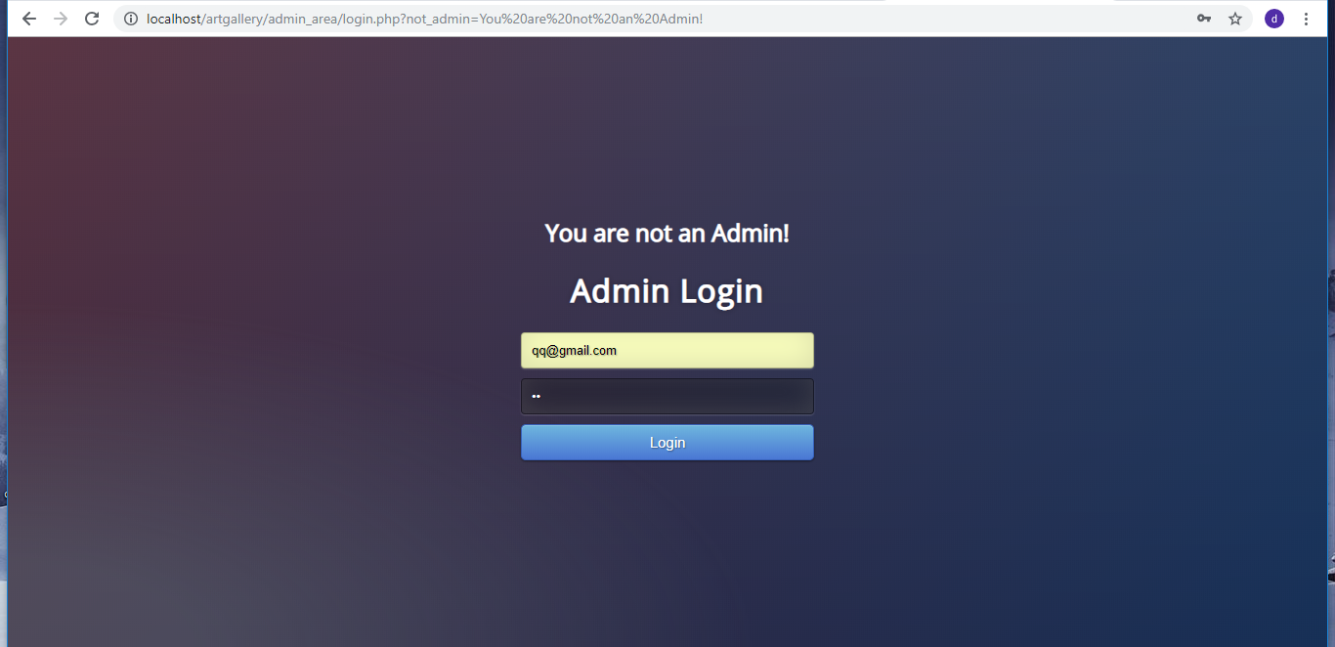

**Figure4.10:** Admin Login Page

Figure4.11 shows the insertion window for painting in admin panel.

**Dept. of CSE, JSSATE**

**Page 20**

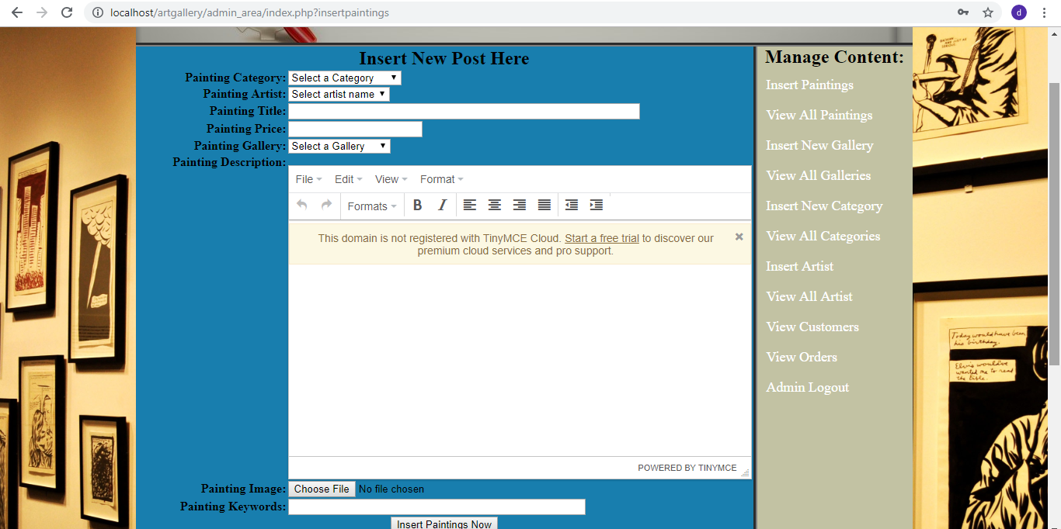

**ART GALLERY MANAGEMENT SYSTEM**

**Figure4.11:** Insert Painting Page

Figure4.12 shows the view all painting window where admin can delete it or edit it.

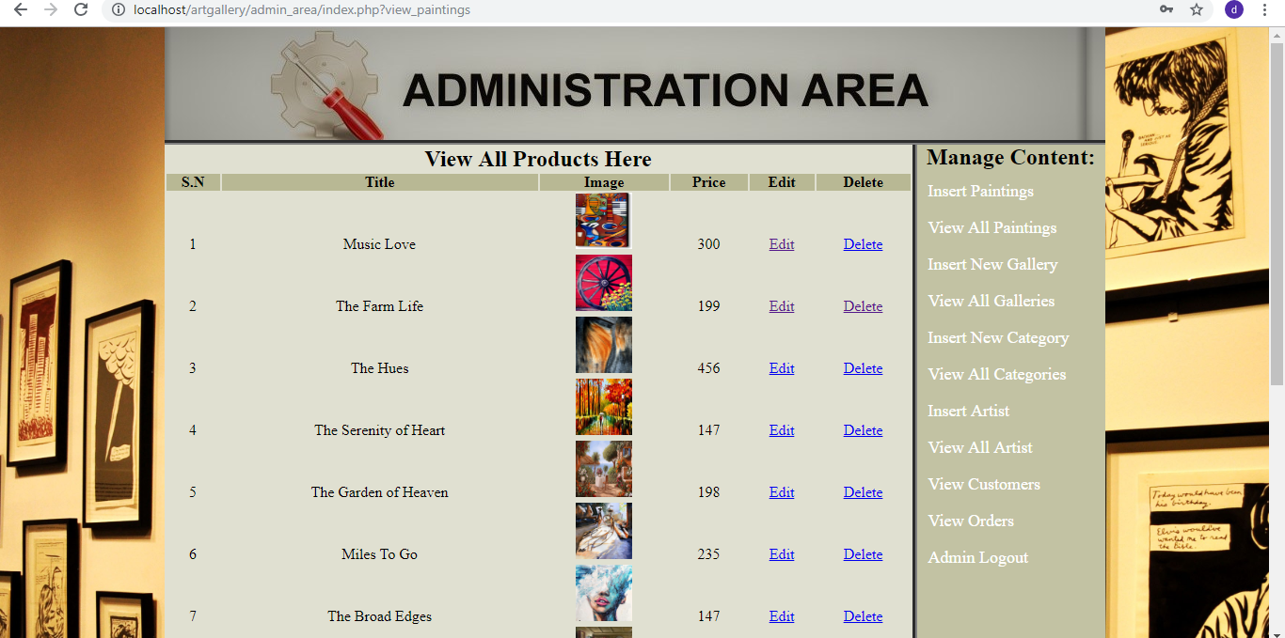

**Figure4.12:** View Painting Page

.

.

**Page 21**

**Dept. of CSE, JSSATE**

**ART GALLERY MANAGEMENT SYSTEM**